Ideation Phase
Define the Problem Statements

Date | 08 August 2026
Name | Shilpa Pachumbre
Project Name | House Rent MERN
Maximum Marks | 2 Marks

Customer Problem Statement Template:
Create a problem statement to understand your users' needs and challenges. The template helps identify real issues faced by Renters and Owners while searching, listing, and booking properties. A well-defined problem statement enables development of an efficient, transparent, and user-friendly House Rent MERN with Admin verification.

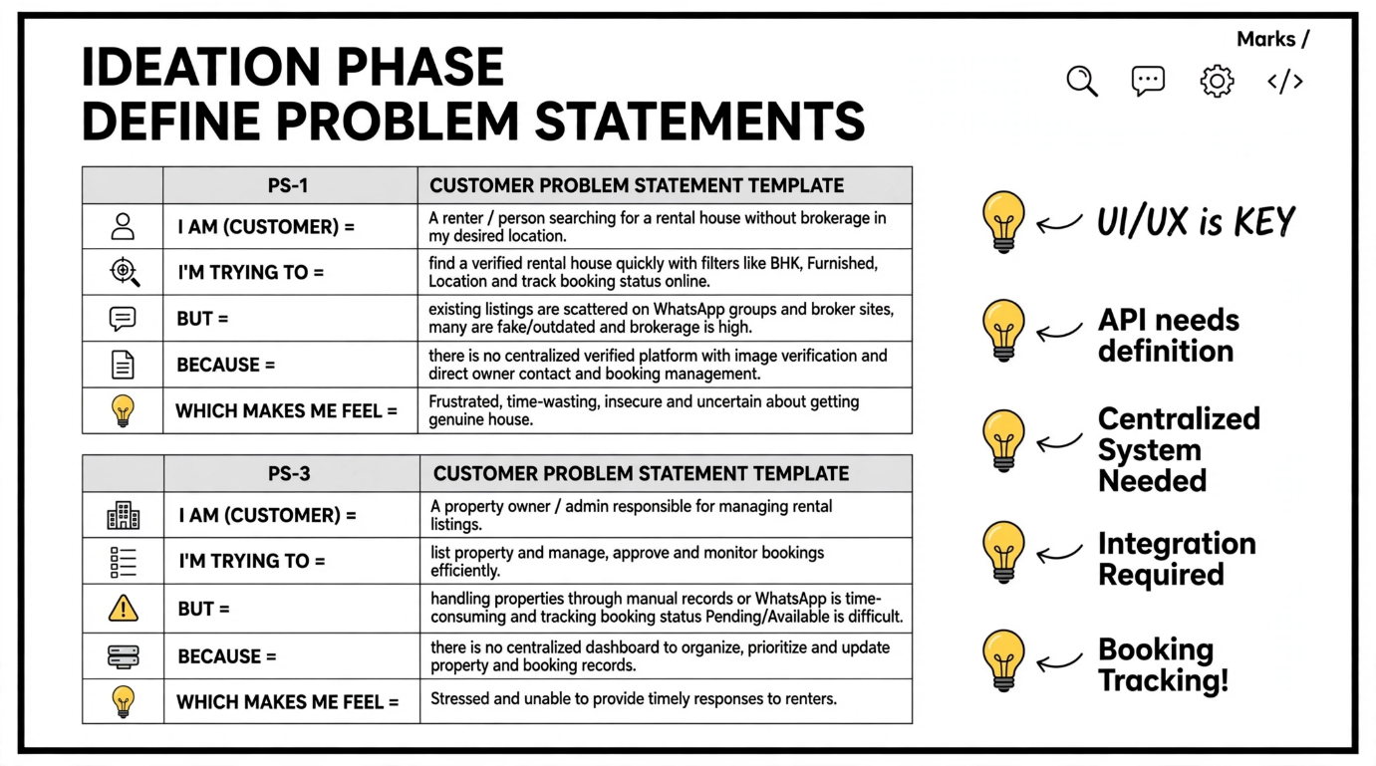

PS ID | I am (Customer) | I'm trying to | But | Because | Which makes me feel
PS-1 | A renter searching for a house in Pune, Satara, Sangli, Karad | find a verified rental house quickly without brokerage using filters like BHK, Furnished, Location and track my booking status | existing listings are scattered on WhatsApp groups and broker sites, listings are fake/outdated and brokerage is high | there is no centralized verified platform with Cloudinary image verification, booking tracking and direct owner contact system | Frustrated, time-wasting, insecure and uncertain about getting a genuine house
PS-2 | A property owner / admin managing listings | list my property and manage bookings efficiently, approve genuine listings and update status Pending/Available | property and booking management is manual, tracking booking requests and status updates is difficult | there is no centralized dashboard (OwnerHome.jsx / AdminHome.jsx) to organize, approve, edit/delete properties and update booking status | Overwhelmed, stressed and unable to provide timely responses to renters

